IRRIGATION and DRAINAGE
Irrigation is the application of water to create a condition in the soil that is favorable for plant growth. It provides the moisture needed by the crop that is not satisfied by rainfall and refers to the controlled application of water for agriculture through man-made systems.
Drainage is the removal of excess water from the soil with the same aim of creating conditions favorable for the growth of crops.

A | BASIC SOIL AND WATER RELATIONS

In a soil system of total volume $V_{T}$ and total weight or mass $W_{T}$:

$$V_{T}=V_{a}+V_{w}+V_{s}$$
$$V_{v}=V_{a}+V_{w}$$
$$W_{T}=W_{a}+W_{w}+W_{s}$$
where:
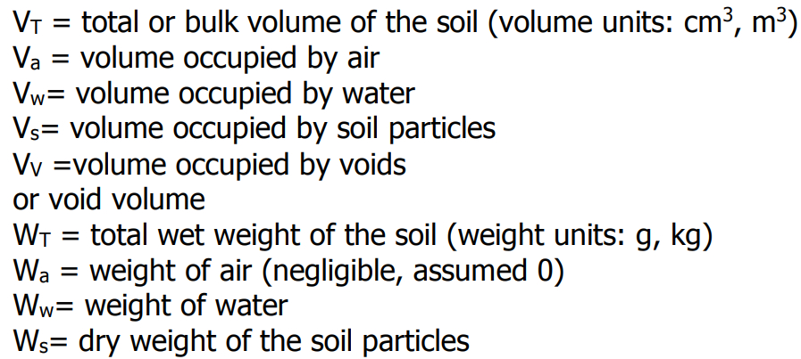

SOIL PROPERTIES

Soil: a storehouse of plant nutrients, a habitat for bacteria, an anchorage for plants, and a reservoir of moisture needed by plants.
Soil Profile: different soil layers from top to bottom
Soil Texture: the relative proportion of primary particles (sand, silt, and clay) in the soil.
Soil Structure: the arrangements of primary particles in the soil into units or peds
Soil Tilth: the physical condition of the soil in relation to plant growth and ease of tillage. Soils in good tilth are cumbly, easily worked and readily take up water and dry.
Porosity (n): the ratio of the void volume to the total soil volume (unitless)
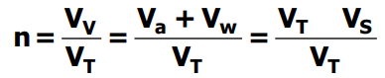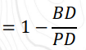
Moisture Content: (unitless)
- On a dry weight basis (${MC}_{w}$): the ratio of weight of water to the dry weight of the soil
- On a volume basis or volumetric moisture content (${MC}_{v}$): the ratio of the volume of water to the total soil volume
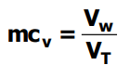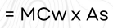
Densities: the mass of soil in a given volume. It indicates how compact or loose the soil is. (g/cm3, kg/m3)
- Bulk density ($ρ_{B}$): the ratio of the dry weight of the soil to the total soil volume
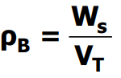= 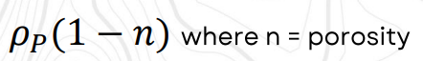
- Particle density ($ρ_{P}$): the ratio of the dry weight of the soil to the volume of the soil particles. (2.65 g/cc is the particle density average value)
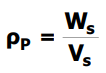
Specific Gravity: ratio of the density of soil solids to the density of water at 4 degrees Celsius (unitless)
- Apparent Specific Gravity ($A_{s}$): ratio of the bulk density of the soil with the density of water; it is ratio of the weight of soil to the weight of water with volume equal to the total soil volume.
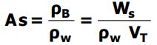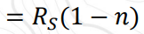
- Real specific Gravity ($R_{s}$): the ratio of the particle density of the soil with the density of water; it is the ratio of the weight of soil to the weight of water with volume equal to the volume of the soil particles alone.
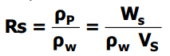
Depth of Water: (mm, cm, m, inch)
- Present in the soil ($d_{w}$): the equivalent depth of water in the soil at a given condition.
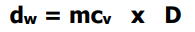
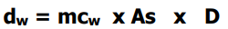
- Needed ($d_{wn}$): to increase the moisture content from an initial value (${mc}_{i}$) to the final value (${mc}_{f}$)


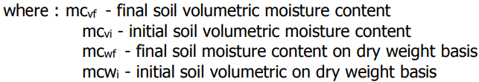

Volume of Irrigation Water ($V_{iw}$): volume of water to be applied to increase the soil moisture content from an initial to final value (liters, cm3, m3)
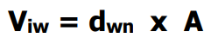
NOTE:
The density of water ($ρ_{w}$) = 1 g/cm3 or 1000 kg/m3
The following relationships hold true:
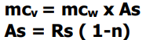

Infiltration Rate: the time rate at which water will percolate into the soil and can expressed in terms of the following empirical equations
- Lewis-Kostiakov Equation
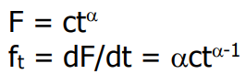

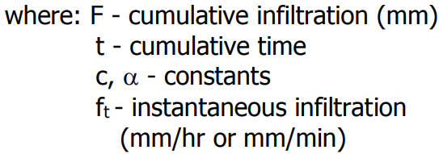
- Horton’s Equation
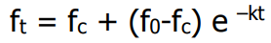
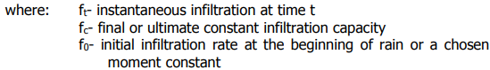

- Philip’s Method
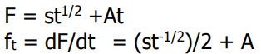
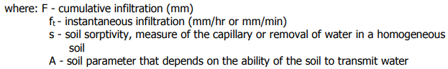

Intake Rate: the rate of infiltration from a furrow into the soil
Permeability: the velocity of flow into the soil caused by a unit hydraulic gradient in which the driving force is one kilogram per kilogram of water.

Adhesion: refers to the attraction of soil particles surface water
Cohesion: attraction of water molecules to each other
Soil Moisture Tension: measure of the forces with which the water is retained in the soil.

1 atmosphere is equal to:
- A pressure of 14.7 psi
- Column of 76.9 cm of mercury
- Column of 34.01 ft or 10.34 m of water

B | SOIL MOISTURE CONSTANT

Saturation Point
- amount of water the soil profile will hold when all its pore spaces are filled up with water.
Field Capacity
- amount of water a soil profile will hold against drainage by gravity at a specified time (usually from 24 to 48 hrs) after a thorough wetting
- the moisture content of the soil when gravitational water has been removed (after irrigation by flooding). It is usually determined few days after irrigation.
- The soil moisture tension at this point is normally between 1/10 to 1/3 atmosphere.
Permanent Wilting Point (or wilting coefficient)
- The soil moisture content when plants permanently wilt.
- Soil moisture tension at this point is about 15 atmospheres.
Available Moisture (AM)
- The difference in moisture content of the soil between field capacity and the permanent wilting point.
Readily Available Moisture (RAM)
- Portion of the available moisture that is most easily extracted by plants
- This is approximately 75% of the available moisture.
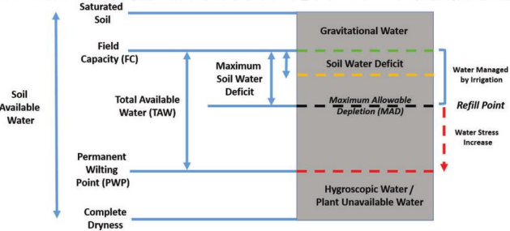
Management Allowed Deficit (MAD)
- The degree to which the amount of water in the soil is allowed to be depleted before the next irrigation is applied.
Soil Moisture Deficit (SMD)/ Soil Water Deficit
- Depletion of soil moisture below field capacity at the time that a particular soil moisture content, Pd, is measured.
Moisture Content Computation
- Amount of moisture present in the soil (mc) given the percent AM content retained or used and the FC and PWP moisture contents of the soil can be computed using the equations:

C | FORMS OF SOIL WATER

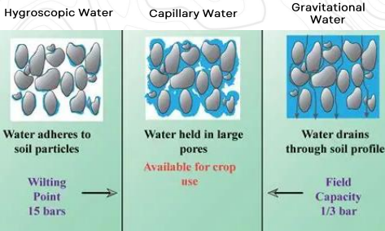

Hygroscopic Water
- Thin film of water tightly bound to soil particles by molecular forces
- Unavailable to plants, because it is held too strongly for roots to extract.
Capillary Water
- Water held in the micropores of the soil by surface tension.
- The main source of water for plants, available between field capacity and permanent wilting point.
Gravitational Water
- Water that drains freely through macropores under the influence of gravity.
- Not available to plants because it drains too quickly after rainfall or irrigation, usually below the root zone.

D | IRRIGATION EFFICIENCIES

Water Conveyance Efficiency: the ratio between the water delivered to the farm and the water diverted from a river or reservoir expressed in percent.
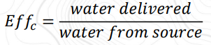
Water Application Efficiency: the ratio between water stored in the soil root zone during irrigation and the water delivered to the farm.
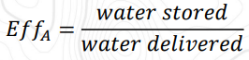
Water-Use Efficiency: ratio of water beneficially used on the project, farm or field to the amount of water delivered to the farm.
Water Storage Efficiency: ratio of water stored in the root zone during the irrigation to the water needed in the root zone prior to irrigation.
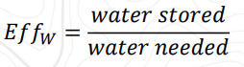

Consumptive Use Efficiency: ratio of the normal consumptive use of water to the net amount of water depleted from the root zone soil.
Water Distribution Efficiency
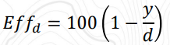
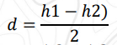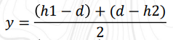



E | PUMP IRRIGATION

Water Horsepower: the power theoretically required to lift a given quantity of water each second to specified height.
Brake Horsepower: water horsepower divided by pump efficiency
Static Head: the difference in elevation of the water surface in a pond, lake, or river from which pumped water is taken, and the water surface of the discharge canal into which the water flows from a submerged discharged pipe. In pumping from groundwater source, static head is the difference in elevation between the water surface in the well and the water surface of the discharged canal.
Total Dynamic Head: the sum of total static head, pressure head, velocity head and friction head.
Drawdown: (in a well) is the difference in elevation between the groundwater table and the water surface at the well when pumping.
Characteristic Curve: graphs that show interrelations between speed, head discharge, and horsepower of a pump.
Specific Speed: expresses the relationship between speed in rpm, discharge in gpm, and head in feet.

F | IRRIGATION PRINCIPLES

CROP WATER REQUIREMENT (CWR)
- Total water needed by a crop during its growth period
- Includes non-consumptive uses and consumptive uses.

Non-Consumptive Uses
- Water for land soaking and preparation
- Losses through:
  - Seepage: lateral water movement along the soil profile
  - Percolation: downward water movement through soil, influenced by soil texture.
- Depends on crop type, soil, climate, and farming practices.

Consumptive Uses
- Evapotranspiration (ET): evaporation + transpiration
Consumptive use is identical with evapotranspiration, for practical purposes. Consumptive use only includes water retained in the plant tissue.

- Evaporation: water loss from soil, water surfaces, and plant surfaces.
- Transpiration: process by which water vapor escapes from living plants, principally by leaves, and enters the atmosphere and water absorbed by roots.

IRRIGATION WATER REQUIEMENT (IWR)
- The irrigation water requirement is the amount of water to be applied to the field as irrigation.
- It can be computed by deducting the effective rainfall (ER) from the total crop water requirement.

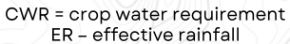

FARM WATER REQUIREMENT (FWR)
- Total amount of water required to raise a crop in the farm for its entire growth period.
  - Crop water requirement (CWR)
  - Water for field reparation, land soaking, percolation, and other farm operations
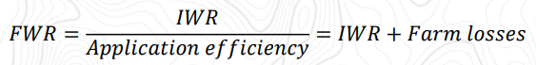

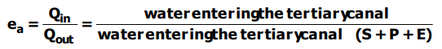
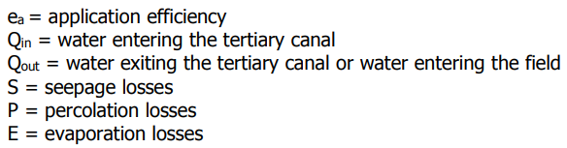

DIVERSION WATER REQUIREMENT (DWR)
- Total water diverted from the source to farm headworks
- Includes conveyance losses (seepage, percolation, evaporation) in main and secondary canals.
- Conveyance efficiency= water reaching tertiary canal/water entering main canal
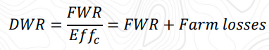

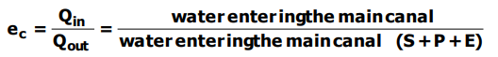

CANAL CAPACITY
- The ability of the stream to provide water determines the extent of the total service area of a national irrigation system.
- The service area of a national irrigation system depends on the stream’s dependable flow divided by the diversion water requirement (DWR)
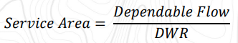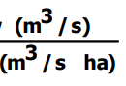
Canal Capacity (Q)
- Flow of a canal delivers per unit time

LEACHING REQUIREMENT (LR)
- Fraction of the irrigation water that must be leached through the root zone to control soil salinity at specified level.
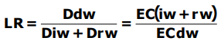
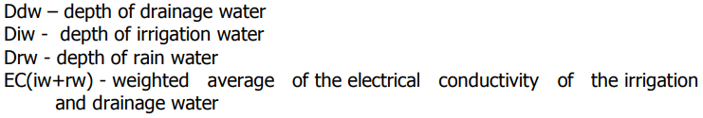
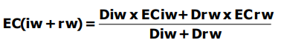
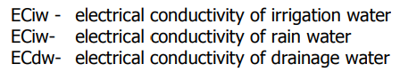

G | MODES OF IRRIGATION

National Irrigation System (NIS): irrigation systems that have relatively large service areas and are managed by government agencies
Communal Irrigation System (CIS): managed and operated by farmers’ or irrigator’ associations.
Shallow Tubewell Irrigation System (STW): pipes vertically set into the ground that abstract groundwater to be used for irrigation, usually owned and operated by individual farmers.

H | METHODS OF IRRIGATION

OVERHEAD IRRIGATION
- Water is applied to the soil surface similar to rainfall
- Watering Can: simplest method, used in small-scale upland farming. Limited to small plots near a water source since water is carried by hand.
- Hose Pipe: required a piped water system and sufficient pressure. Main drawback is high water cost.
- Sprinkler Irrigation: this method is the application of water to the surface of the soil in the form of spray, simulating that of rain. Water sprayed under pressure through nozzles. Pumping usually provides pressure. Proper nozzle size, pressure, and spacing ensure uniform application at a rate matching soil infiltration for efficient irrigation.

FURROWS
- Wets only a part of the ground surface
- Furrow irrigation: It is accomplished by running water through small channels or furrows while it moves down or across the slope of the field. The water sips into the bottom and sides of the furrows to provide the desired wetting. Careful land grading for uniform slopes is essential with this method.
- Corrugation Irrigation: It is a variation of the furrow method and it uses small rills or corrugations for irrigating closely spaced crops, such as small grains and pastures. The water seeps laterally through the soil, wetting the area between the corrugations.

FLOODING
- Wets the entire land surface
- Ordinary Flooding: Water is applied from field ditches to guide its flow and it is difficult to attain high irrigation efficiency using this method. The chief advantage of this method is its low initial cost of preparing the land.
- Border-Strip Flooding: A field is divided into a series of strips by borders or ridges running down the predominant slope or on the contour. To irrigate, water is released into the head of the border. The water, confined and guided by two adjacent borders, advances in a thin sheet toward the lower end of the strip. The objective is to allow a sheet of water to advance down the narrow strip of land, allowing it to enter the soil as the water advances.
- Level-Border or Basin Irrigation: Water is supplied to level plots surrounded by dikes or levees. This method is particularly useful on fine textured soils with low permeability; it is necessary to hold the water on the surface to secure adequate penetration.
- Contour-Ditch Irrigation: It involves controlled flooding from field ditches along the contour of the land, which allows the water to flood down the slope between field ditches without employing dikes or other means that guide or restrict its movement.

DRIP OR TRICKLE IRRIGATION
- the water is directed to the base of the plant. Water is applied to the soil through small orifices. The small orifices, often called emitters, are designed to discharge water at rates of 1 to 8 liters per hour. Water is delivered to the orifices through plastic pipelines, which are generally laid on the soil surface or buried. The rate of discharge is determined by the size of the orifice and the pressure in the pipelines. This method is particularly beneficial for young orchards, vineyards, closed-spaced perennials, and other crops of high value and in areas where water is scarce or has a high salt content. A highly efficient water utilization can be achieved with this method, bit it is very expensive.

SUB-IRRIGATION
- the surface is rarely wet since the water is supplied from the soil underneath. This requires complete control of the water table so that the root zone is kept relatively free of excess water but is continually supplied with capillary moisture during the cropping season.

RECOMMENDED SLOPE FOR DIFFERENT IRRIGATION METHOD

Furrow: 0.05% - 3.0%
Border: 2.0% - 5.0%
Basin <= 0.1%

I | PRESSURE

Average Pressure: average sprinkler pressure of a lateral
Design Pressure: pressure required to overcome the elevation difference between the water source and the sprinkler nozzle, to counteract friction losses and to provide adequate pressure at the nozzle for good water distribution.

Distribution Uniformity: numerical value on the uniformity of application for agricultural irrigation systems
Irrigation Period: time required to cover an area with one application of water.
Wetted Diameter: diameter of the circular area wetted by the sprinkler when operating at a given pressure and no wind.

J | SPRINKLER IRRIGATION SYSTEM

IMPACT SPRINKLER
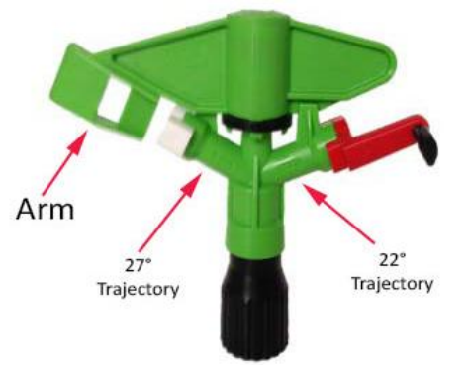
COMPONENTS OF SPRINKLER IRRIGATION SYSTEM
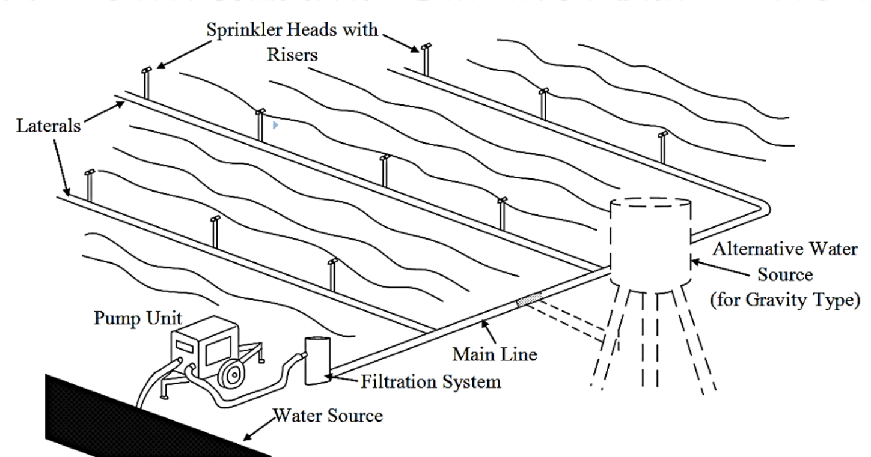

Pump Unit
Delivers water from the source to the pipe system at an adequate capacity
Filtration System
Consists of screen openings considerably lower than the nozzle diameter to prevent nozzles from clogging.
Sprinklers
Device of various nozzle sizes which spray water over the ground or crop.
Mainline and Submainlaines
Pipe which conveys water from the pump to the laterals
Laterals
Deliver water from the mainlines o submainlines to the sprinkler

TYPE OF SPRINKLER SYSTEM

Set System
operate with sprinklers set in a fixed position
- Periodic- Move System: sprinklers that must be moved manually through a series of positions during the course of irrigation
- Hand-Move System: composed of portable or buried pipe with valve outlet at intervals for attaching the portable laterals.
- Mechanical- Move System
- Side- Roll Lateral System: lateral pipes act as axles with wheels at each joint, powered by a central engine.
- End- Tow Lateral System: rigid laterals connected to a central buried mainline, towed in an “S” pattern across the field.
- Gun and Boom Sprinkler System: nozzles on long discharge tubes rotate via a rocker arm drive.

Fixed System
Sprinkler systems not requiring to be moved during the course of irrigation.

Continuous Move System
Sprinklers operate while moving continuously, either in a circular or straight path.
- Center Pivot: a lateral pipeline rotates around a fixed pivot point connected to the water source, irrigating a circular area.
- Linear Move: similar to center pivot but moves in a straight line with a travelling water-feed system.
- Travelling: a high-capacity sprinkler mounted on a self-powered chassis, moves along a straight line with water supplied by a flexible hose.

MAXIMUM SPRINKLER SPACING AS RELATED TO WIND VELOCITY, RECTANGULAR PATTERN
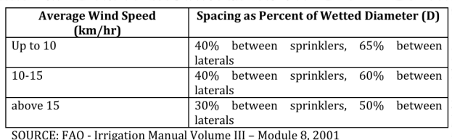
MAXIMUM SPRINKLER SPACING AS RELATED TO WIND VELOCITY, SQUARE PATTERN
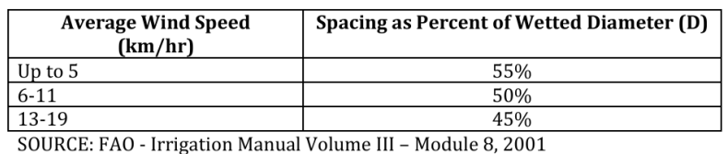

SPRINKLER THROW
$$Throw=\frac{L+W(\%overlap)}{2}$$

K | EMITTER

TYPES OF EMITTERS

Based on pressure dissipation mechanism
  - Long-path: water passes through a long, narrow passage under laminar flow to reduce pressure and maintain uniform flow; flow area: 1mm2 to 4.5mm2
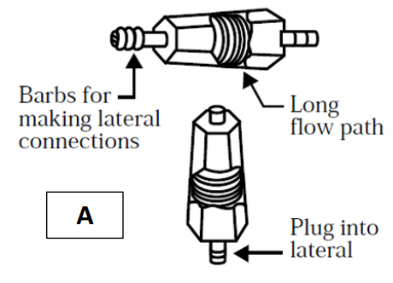
  - Tortuous: has long, winding paths with larger cross-section; flow is turbulent
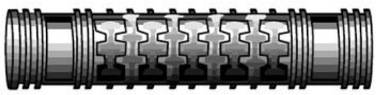
  - Short-path: similar to long-path but with shorter water path; ideal for very low-pressure systems
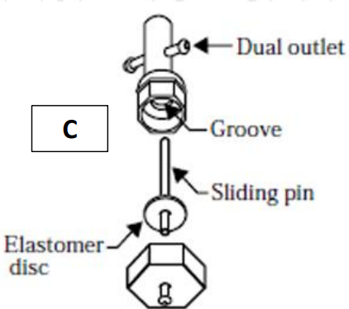
  - Orifice: water exits as a fully turbulent jet, broken into drops; flow area: 0.2mm2 to 0.35mm2
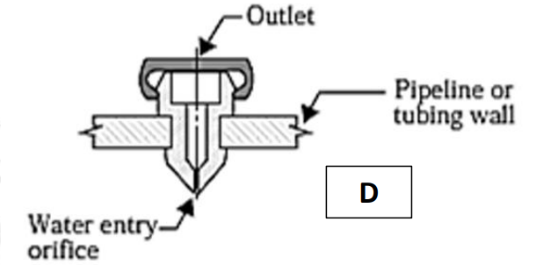
  - Vortex: water moves in a circular path creating a vortex; high head losses allow larger openings

Based on the ability to flush
- On-off Flushing: flushes for a few moments each time the system is started and again when turned off
- Continuous Flushing: eject large particles during operation since this type has relatively large diameter flexible orifices in series to dissipate pressure.

Based on the connection to the lateral
- On-line: intended for direct or indirect installation in the wall of the irrigation lateral
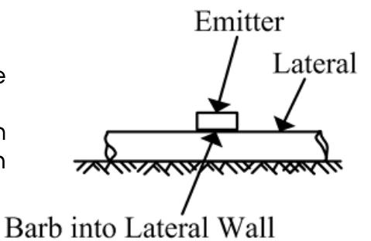
- In-line: intended for installation between laterals
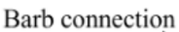
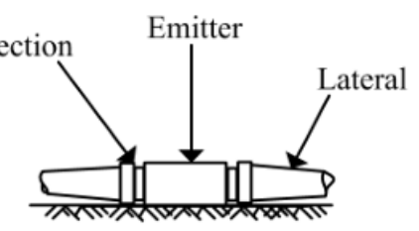

Based on field application
- Line-source: water discharged from closely spaced perforations, emitters, or porous wall along the lateral line
- Point-source: water discharged from individual emission points that are relatively widely spaced (usually >1m apart).
- Multiple-outlet emitters: deliver water at two or more emission points.

DISCHAGE AND PRESSURE RELATIONSHIP

$$Q=K_{d} x H^{x}$$

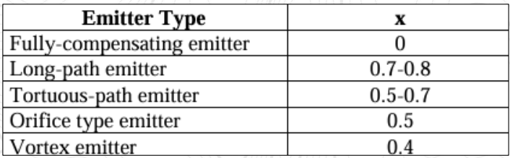

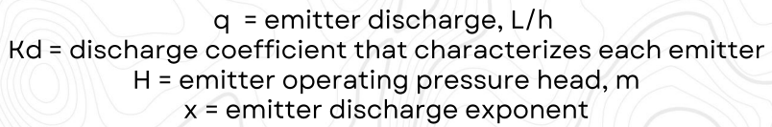

L | CLASSIFICATION BASED ON FUNCTION

DIVERSION STRUCTURES

Diversion Dams
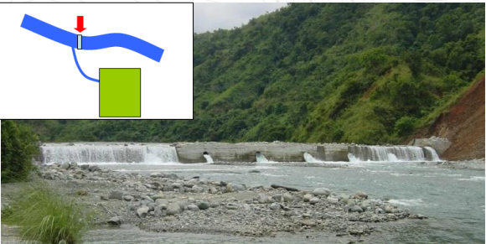
- Structure built across a river or stream for diverting the streamflow into a canal
- Raises the water level upstream of the water to a desired height so that water could be diverted to the conveyance channels by gravity
- It has a headgate for regulating the entry of water into the canal
- Permanent dams are usually made of concrete while temporary dams are generally of boulders, stones and brush

Check Gates
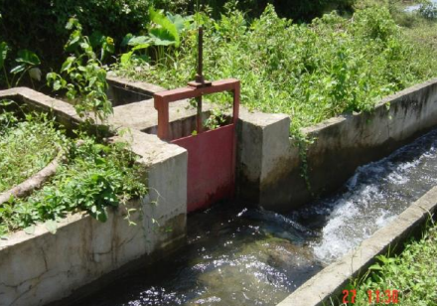
- Structures used to raise the upstream water level in a canal above its natural level during periods of low discharges to enable water to flow to the head works of the different canals branching from the main canal, laterals or sublaterals
- Usually built along he stretches or irrigation canal immediately downstream of head gates and turnouts

End Check
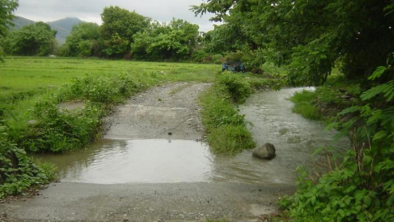
- Structures installed at the downstream end of a farm ditch to check the direct flow of excess irrigation water into the drainage canals.
- It is consists of a fall structure combined with a pipe culvert under the canal embankment.

DISCHARGE MEASUREMENT STRUCTURES

Weirs
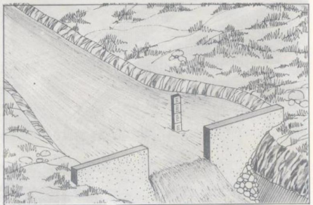
- Flow measuring structures that are placed across the open channel to constrict the flow and allow it to pass over the crest

Parshall Flumes
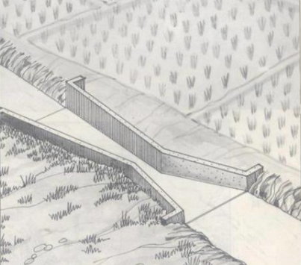
- An open channel measuring structure in which canal water flows over a wide, flat converging section that widens at the outlet end.

DISCHARGE REGULATING STRUCTURES

Headgates or Head Regulators
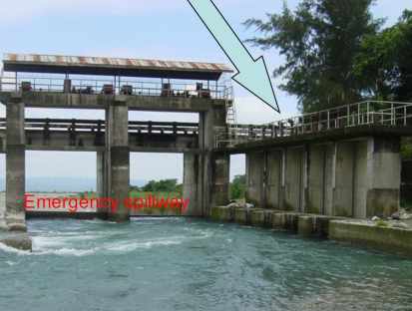
- Structures installed at the head of conveyance canals or main canals to regulate the amount of water to be distributed
- Used to meter the amount of water flowing through them
- During floods, headgates should be closed to prevent overtopping of canals and entry of debris which clog the structures; the sluiceway should also be opened to prevent accumulation of debris in front of the headgate.

Turnouts
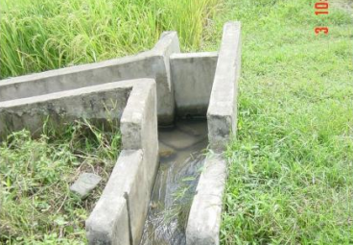
- Serve as an outlet of water in irrigation canals whereby water passes through and discharges into the main farm ditch or service area

Intake Structures
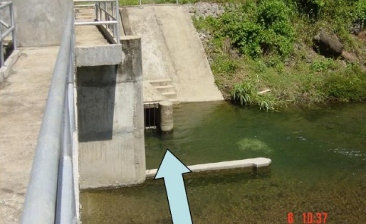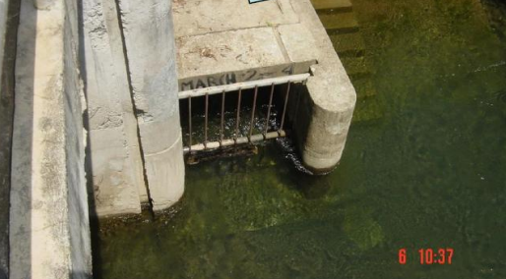

- A concrete structure usually built along the bank of the river or stream and which draws water to be channeled into an irrigation system
- An intake structure without a dam is applicable only in cases where only a small portion of the streamflow will be taken and the existing water level is sufficiently high to allow diversion of water

FLOW DIVING STRUCTURES (DISTRIBUTION STRUCTURES)

Division Boxes
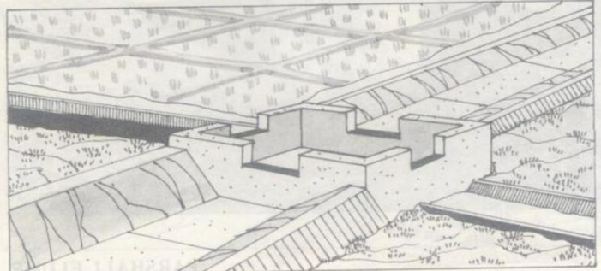
- Rectangular structure which is usually built along the main farm ditch to divide and distribute the flow to the supplementary farm ditches

MISCELLANEOUS STRUCTURES (CONVEYANCE STRUCTURES)

Inverted Siphons
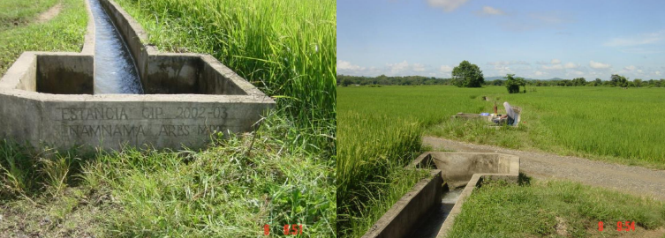
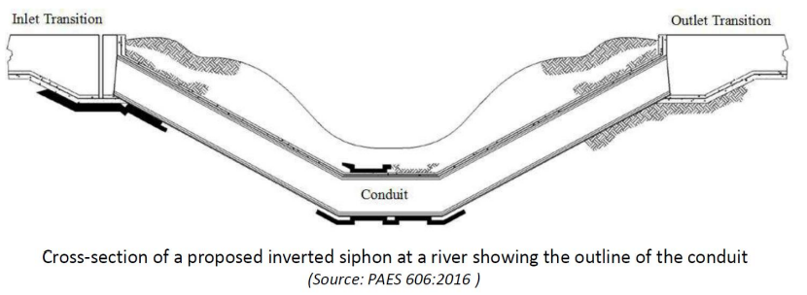
- Closed conduit designed to convey canal water in full and under pressure running condition, to convey canal water by gravity under roadways, railways, drainage channels and local depressions.

Flumes
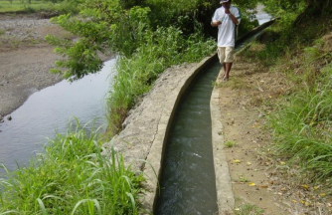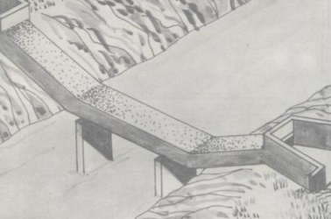
- Elevated flume: used to convey irrigation water across and above natural depressions such as rivers or creeks
- Bench flume: usually a rectangular concrete through supported on a bench excavated into a hillside and through which water flows into an adjoining canal
- SI-flume: a combination siphon and flume that conveys water across a depression, drainage canal or stream usually from a higher to lower opposite bank; usually a closed rectangular reinforced concrete conduit supported above by the ground columns or piers

Crossings
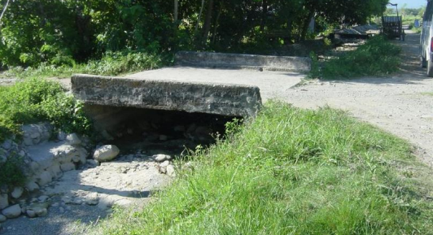
- Structure constructed across irrigation canals for traffic crossing by man, animal, cart, or vehicles

Drops/Chute
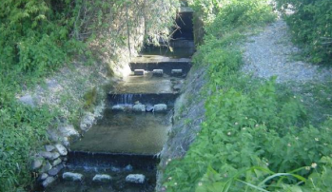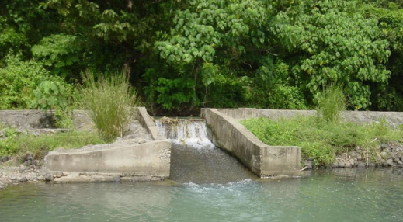
- Used to conduct water from a higher to a lower elevation and to diffuse the force of the falling water; hence it is constructed on steeply sloping land to prevent channel scouring and erosion
- The inlet of the structure also serves as a control to regulate the water depth in the canal upstream

OTHER STRUCTURES WITH FUNCTION
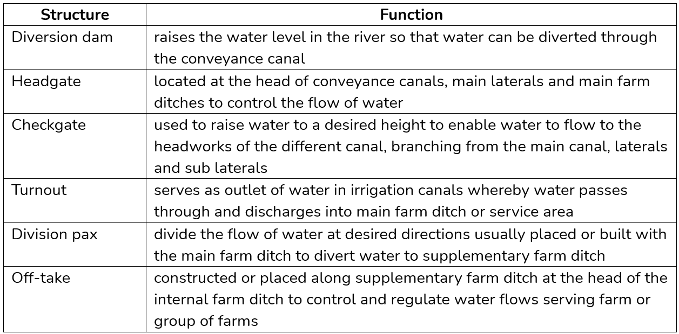
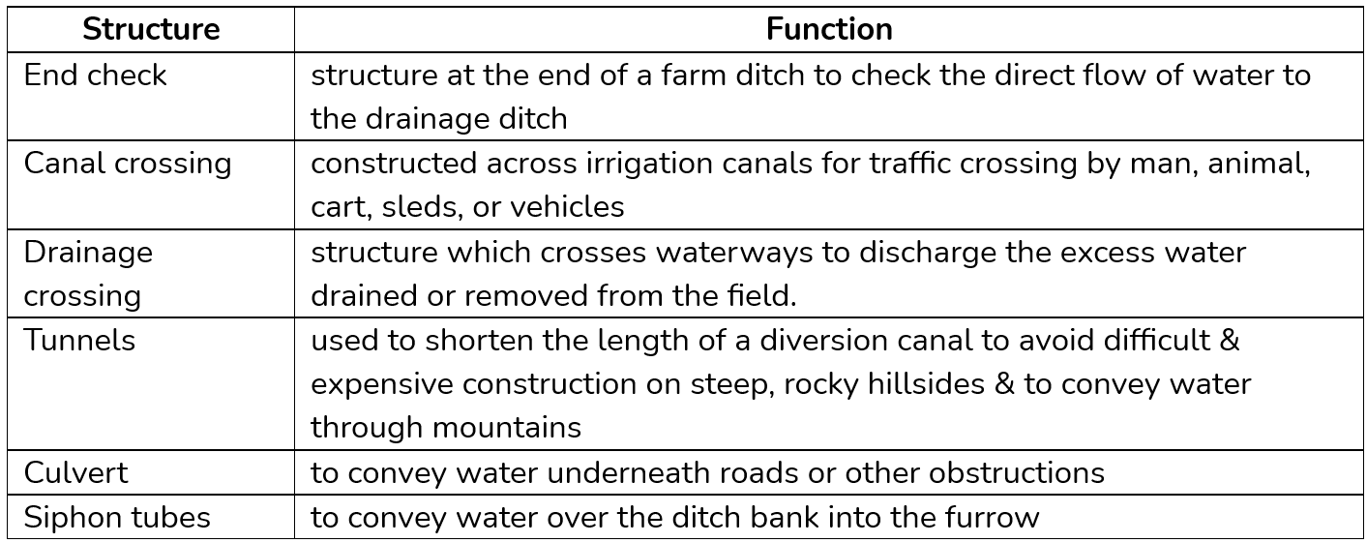
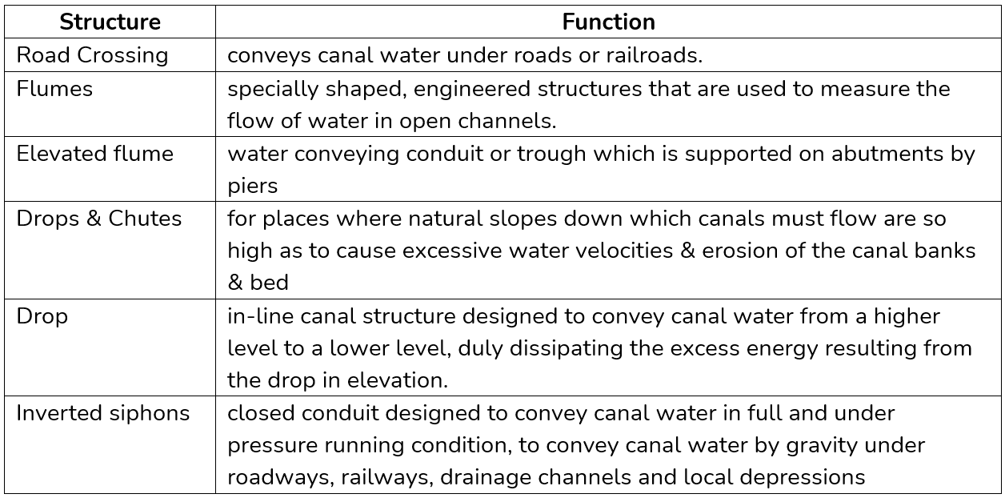

M | TYPES OF SURFACE FIELD DRAINAGE SYSTEM OR OPEN DRAINS

Bedding System: The soil type largely influences the width of bed to be used. The furrows drain to collection ditches.

Random Ditch System: This system is adapted to areas that have depressions which are too deep or too large to fill by land leveling. The ditches meander from one low spot to another, collecting the water and carrying it to an outlet ditch.

Interception or Cross-Slope System: This resembles terracing in that the drainage ditches are constructed around the slope on a uniform grade according to the land topography. The ditches should be constructed across the slope as straight and parallels the topography permits.

Diversion or Parallel Ditch System: This is suitable on flat, poorly drained soils that have numerous shallow depressions. In general, the ditches are 185 m to a maximum of 370 m apart (not necessarily equidistant) and the land in between the parallel ditches is sloped and smoothed to eliminate any minor depressions or obstructions to the overland flow of the water.

N | LAYOUT OF A TILE=DRAIN SYSTEM OR CLOSED DRAINS

Natural System: used in rolling topography where drainage is necessary only in small valleys.

Gridiron Layout: used if the entire area is to be drained and is usually more economic. Laterals enter the submain from one side only to minimize the double drainage that occurs near the submain.

Herringbone Pattern: The submain is laid in a depression and the laterals join the submain from each side alternately. The land along the submain is double drained, but since it is in a depression, it probably requires more drainage.

Double-Main System: This system is often used if the bottom of the depression is wide since it reduces the lengths of the laterals and eliminates the break in slope of the laterals at the edge of the depression.

Interception Drain: This is used if the main source of excess water is drainage from hill lands. The drains are placed along the toe of the slope to protect the bottom land.

Arrangement to Avoid Trees: This system is adopted to minimize the exposure of the laterals to the hazard posed by root of trees which easily enter the open joints of underdrains. Mains and laterals were kept well away from trees.

O | DRAIN SPACING EQUATIONS

STEADY STATE
Drain Bottom Reaching Impermeable Layer (DBRIL)
    - With recharge, unconfined aquifer condition, drain levels of same elevation
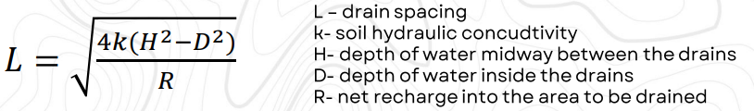

    - no recharge, unconfined aquifer condition, drain levels of unequal elevation (unidirectional flow to lower level)
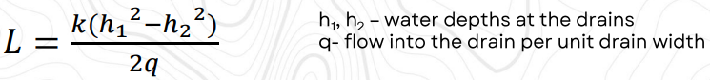

    - no recharge, confined aquifer condition, drain levels of unequal elevation (unidirectional flow to lower level)
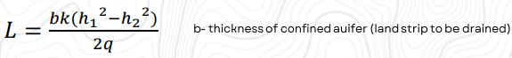

    - with recharge, unconfined aquifer condition, drain levels of equal elevation
- flow to left drain
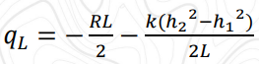
- flow to right drain
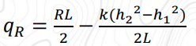
- elevation of the water table (h) at any pointy x
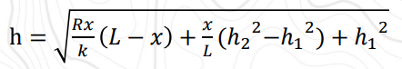
- stagnation point
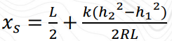
- maximum elevation of the water table (hmax)
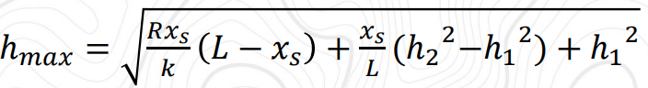
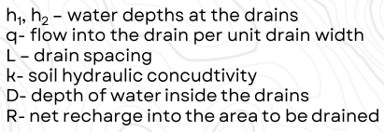

Drain Bottom Not Reaching Impermeable Layer (DBNRIL)
Hooghoudt’s Equation
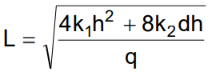
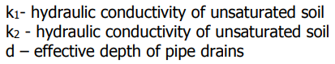

UNSTEADY STATE

Glover-Dumm Formula
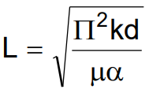
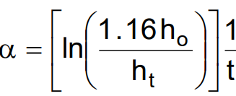
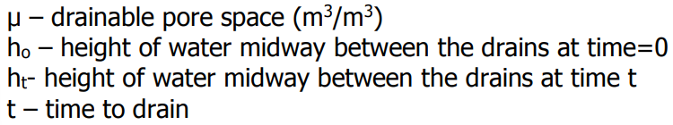

P | IRRIGATION WATER REQUIREMENT AND RELATED FORMULAS

LAND SOKAING REQUIREMENT

$$LSR=[n- (RMC x As)] x Drz$$
$${LSR}_{net}=\frac{[n- (RMC x As)] x Drz}{∆T}$$
$${LSR}_{gross}={LSR}_{net}+ET+P$$

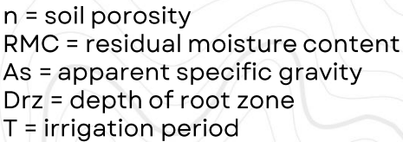
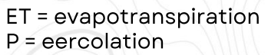

LAND PREPARATION WATER REQUIREMENT

$$LPWR=LSR+SW+ETo$$
$$SW=standing water$$
$$Eto=Reference Evapotranspiration$$

FARM IRRIGATION REQUIREMENT

$$FIR=\frac{CU-ER}{1-FL}$$

DIVERSION WATER REQUIREMENT

$$DWR=\frac{FIR x A}{1-CL}$$
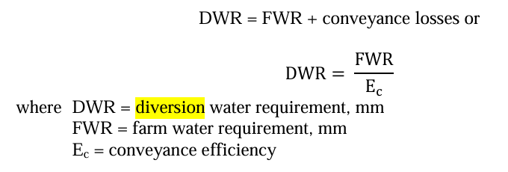

NET APPLICATION DEPTH

$$d_{net}=(FC-PWP)(MAD)(Drz)$$
$$d_{net}=(RAM)(WHC)(Drz)$$
$$d_{net}=(MCv)(Drz)$$

GROSS DEPTH APPLICATION

$$d_{gross}=\frac{d_{net}}{E_{a}}$$

IRRIGATION INTERVAL

$$I_{i}=\frac{d_{net}}{CU}=\frac{d_{net}}{ETcrop}=\frac{(FC-PWP)(MAD)(Drz)}{CU}=\frac{\left(RAM\right)\left(WHC\right)(Drz)}{ETcrop}$$

IRRIGATION PERIOD

$$I_{p}=\frac{{A x d}_{gross}}{Q}$$

IRRIGATION EFFICIENCY

$$I_{eff}=\frac{CU-ER}{Wf}$$
CU, ER, Wf unit in m3

Q | SOME IRRIGATION TERMS (RA 8435)

- Communal Irrigation System (CIS) - an irrigation system that is managed by a bonaf0ide Irrigators’ Association
- Headworks - the composite parts of the irrigation system that divert water from natural bodies of water such as rivers, streams, and lakes
- Irrigable Lands - lands which display marked characteristics justifying the operation of an irrigation system
- Irrigated Lands - lands serviced by natural irrigation or irrigation facilities. These include land where water is not readily available as existing irrigation facilities need rehabilitation or upgrading or where irrigation water is not available year-round
- Irrigation System - a system of irrigation facilities covering contiguous areas
- Irrigators’ Association (IA) - an association of farmers within a contiguous area served by a National Irrigation System or Communal Irrigation System
- Main Canal - the channel where diverted water from a source flow to the intended area to be irrigated
- National Irrigation System (NIS) - a major irrigation system managed by the National Irrigation Administration
- On-Farm Irrigation Facilities - composite facilities that permit entry of water to paddy areas and consist of farm ditches and turnouts
- Secondary Canal - the channel connected to the main canal which distributes irrigation to specific areas
- Shallow Tubewell (STW) - a tube or shaft vertically set into the ground for the purpose of bringing groundwater to the soil surface from a depth of less than 20 meters by suction lifting

